**SECTION A**

1. What happens to matter when it is heated?

……………………………………………………………………………………………………………………………………………………

…………………………………………………………………………………………………………………….…………………………

1. Why are weaning babies said to be vulnerable?

……………………………………………………………………………………………………………………………………………………

…………………………………………………………………………………………………………………….…………………………

1. 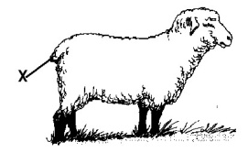**The diagram below shows an animal farm practice. Name it.**

…………………………………………………………………………………………………………………

1. Why is it necessary for plants to lose water through transpiration?

……………………………………………………………………………………………………………………………………………………

…………………………………………………………………………………………………………………….…………………………

1. Mention one role of a mother in a home.

………………………………………………………………………………………………………………………………………………… ……………………………………………………………………………………………………………………….…………………………

1. How do other crops benefit from the growing of legumes in a garden?

……………………………………………………………………………………………………………………………………………………

…………………………………………………………………………………………………………………….…………………………

1. Give any one behaviour that made Mustapha, a livestock farmer to suspect that his cow is on heat.

……………………………………………………………………………………………………………………………………………………

…………………………………………………………………………………………………………………….…………………………

1. Where in the alimentary canal does the absorption of water take place?

……………………………………………………………………………………………………………………………………………………

…………………………………………………………………………………………………………………….…………………………

1. How important is a screen on a VIP latrine?

……………………………………………………………………………………………………………………………………………………

…………………………………………………………………………………………………………………….…………………………

1. Give one way in which air is used as an energy resource.

……………………………………………………………………………………………………………………………………………………

…………………………………………………………………………………………………………………….…………………………

1. How do forests help in reducing the effect of global warming?

……………………………………………………………………………………………………………………………………………………

…………………………………………………………………………………………………………………….…………………………

1. Give one way in which the tools below are helpful to a casualty.

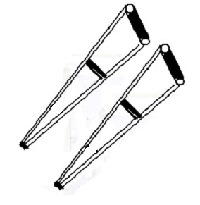……………………………………………………………………………………………………….

……………………………………………………………………………….………………………

1. How do we call static electricity in nature?

……………………………………………………………………………………………………………………………………………………

…………………………………………………………………………………………………………………….…………………………

1. Write HIV in full.

……………………………………………………………………………………………………………………………………………………

…………………………………………………………………………………………………………………….…………………………

1. Why is a magnet placed under a paper able to attract pins on the paper?

……………………………………………………………………………………………………………………………………………………

…………………………………………………………………………………………………………………….…………………………

**The diagram below is of a housefly.**

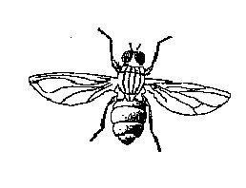

How is its larva useful to humans?

16.

……………………………………………………………………………………………………………………………………………………

…………………………………………………………………………………………………………………….…………………………

1. How important are halterers to an insect?

…………………………………………………………………………………………………………………………………………………… …………………………………………………………………………………………………………….………….…………………………

1. What first aid is appropriate for a person with fever?

…………………………………………………………………………………………………………………………………………………….

1. Why are there few houseflies in a VIP latrine?

……………………………………………………………………………………………………………………………………………………

…………………………………………………………………………………………………………………….…………………………

1. Name one commonly abused drug.

……………………………………………………………………………………………………………………………………………………

…………………………………………………………………………………………………………………….…………………………

1. Which fuel is commonly used for cooking in villages?

……………………………………………………………………………………………………………………………………………………

…………………………………………………………………………………………………………………….…………………………

1. Which part of the body is affected by scabies?

……………………………………………………………………………………………………………………………………………………

…………………………………………………………………………………………………………………….…………………………

1. What are invertebrates?

……………………………………………………………………………………………………………………………………………………

…………………………………………………………………………………………………………………….…………………………

1. Mabira placed a bowl of water under the sun and noted the level. In the evening, he was surprised to find that the water level had gone low. State why it was so.

……………………………………………………………………………………………………………………………………………………

…………………………………………………………………………………………………………………….…………………………

1. Mention one food stuff suitable for brick makers.

……………………………………………………………………………………………………………………………………………………

…………………………………………………………………………………………………………………….…………………………

1. Give a reason for your answer in (25) above.

……………………………………………………………………………………………………………………………………………………

…………………………………………………………………………………………………………………….……………………

1. How is family planning important to a nation like Uganda?

…………………………………………………………………………………………………………………………………………………… …………………………………………………………………………………………………………………….…………………………

1. Explain the term drowning.

……………………………………………………………………………………………………………………………………………………

…………………………………………………………………………………………………………………….…………………………

1. Give one energy change that takes place in bulb as it gives light.

……………………………………………………………………………………………………………………………………………………

…………………………………………………………………………………………………………………….…………………………

1. How can you increase milk production in a dairy cow?

……………………………………………………………………………………………………………………………………………………

…………………………………………………………………………………………………………………….…………………………

1. What can one use it put out petrol fire?

……………………………………………………………………………………………………………………………………………………

…………………………………………………………………………………………………………………….…………………………

1. If a box of mass 25g is immersed in an overflow can and it displaces 5cc of water, find its density.
2. Why is bush fallowing an important practice in farming?

……………………………………………………………………………………………………………………………………………………

…………………………………………………………………………………………………………………….…………………………

1. How can the problem of anaemia be immediately solved in bleeding patients?

……………………………………………………………………………………………………………………………………………………

…………………………………………………………………………………………………………………….…………………………

1. Give one way in which air is bad to human health.

……………………………………………………………………………………………………………………………………………………

…………………………………………………………………………………………………………………….…………………………

1. **In the space provided below, draw a diagram showing regular reflection**.
2. **To which group of birds does the one below belon**g?

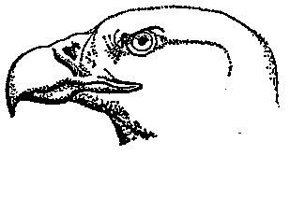…………………………………………………………………………………………………………

1. How is the strong sharp hooked beak important to the above bird?

……………………………………………………………………………………………………………………………………………………

1. What name is given to the path taken by the flow of elections?

………………………………………………………………………………………………………………………………………………….

1. Why is it necessary to sleep under a mosquito net?

……………………………………………………………………………………………………………………………………………………

…………………………………………………………………………………………………………………….………………………… **SECTION B**

41(a) Name two types of chicken reared in Uganda.

1. ………………………………………………………………………………………………………………………………………………..
2. ………………………………………………………………………………………………………………………………………………

(b) Give a reason for which the chicken named in (a) above is kept.

1. ……………………………………………………………………………………………………………………………………………….
2. ……………………………………………………………………………………………………………………………………………… 42 **Complete the table below correctly.**

|  |  |  |
| --- | --- | --- |
| **Disease** | **Vaccine** | **Site** |
| **Poliomyelitis** | **………………………………..** | **Mouth** |
| **Tetanus** | **DPT vaccine** | **……………………………………………..** |
| **………………………………………………** | **BCG vaccine** | **Right upper arm** |
| **Measles** | **Measles vaccine** | **..............................** |

1. **The diagram below shows one of the methods used in making magnets.**

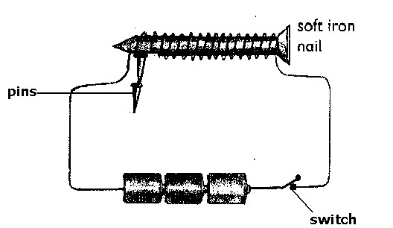

* 1. Name the method.

…………………………………………………………………………………………………………………….…………………………

* 1. What form of energy is used in the making of the magnet?

……………………………………………………………………………………………………………………………………………………

…………………………………………………………………………………………………………………….…………………………

* 1. What happens to the pins when the switch is turned off?

……………………………………………………………………………………………………………………………………………………

…………………………………………………………………………………………………………………….…………………………

* 1. Name the pole on which the pins are attached.

……………………………………………………………………………………………………………………………………………………

…………………………………………………………………………………………………………………….…………………………

1. **The diagram below is of a mammalian ear. Use it to answer the following questions.**

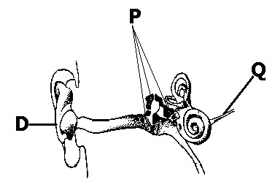

1. What collective name is given to P?
2. ……………………………………………………………………………………………………………………………………………………

…………………………………………………………………………………………………………………….…………………………

1. In which way is Q important in the process of hearing?

……………………………………………………………………………………………………………………………………………………

…………………………………………………………………………………………………………………….…………………………

1. State the function of D.

……………………………………………………………………………………………………………………………………………………

…………………………………………………………………………………………………………………….…………………………

1. What would happen if one’s ear drum got torn?

……………………………………………………………………………………………………………………………………………………

…………………………………………………………………………………………………………………….…………………………

45. Rearing livestock is one way of eradicating poverty.

1. Give one example of livestock you know.

……………………………………………………………………………………………………………………………………………………

…………………………………………………………………………………………………………………….…………………………

1. Why do you think rearing livestock can help in reducing poverty?

……………………………………………………………………………………………………………………………………………………

…………………………………………………………………………………………………………………….…………………………

1. Mention one problem faced by livestock farmers.

……………………………………………………………………………………………………………………………………………………

…………………………………………………………………………………………………………………….…………………………

1. How has the problem in (C) above been solved?

……………………………………………………………………………………………………………………………………………………

…………………………………………………………………………………………………………………….…………………………

46(a) How is alcohol made in your community?

……………………………………………………………………………………………………………………………………………………

…………………………………………………………………………………………………………………….…………………………

1. Which type of alcohol is commonly used as a fuel?

……………………………………………………………………………………………………………………………………………………

…………………………………………………………………………………………………………………….…………………………

1. In which part of an alimentary canal is alcohol absorbed?

……………………………………………………………………………………………………………………………………………………

…………………………………………………………………………………………………………………….…………………………

1. How is alcohol dangerous to an individual? ……………………………………………………………………………………………………………………………………………………

…………………………………………………………………………………………………………………….…………………………

47. **The diagram below shows an electric circuit.**

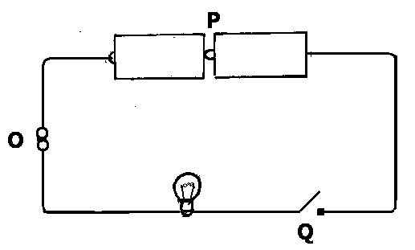

1. What happens to the bulb when Q is closed?

……………………………………………………………………………………………………………………………………………………

…………………………………………………………………………………………………………………….…………………………

1. What form of energy is produced in P?

……………………………………………………………………………………………………………………………………………………

1. How is O useful in the circuit?

……………………………………………………………………………………………………………………………………………………

1. Use an arrow head to show the direction of current flow.

48(a) By merely looking at a plant growing, what makes one believe that a plant is a monocot?

……………………………………………………………………………………………………………………………………………………

…………………………………………………………………………………………………………………….…………………………

1. Identify an example of a plant described above.

……………………………………………………………………………………………………………………………………………………

…………………………………………………………………………………………………………………….…………………………

1. What class of food are such plants rich in?

……………………………………………………………………………………………………………………………………………………

…………………………………………………………………………………………………………………….…………………………

1. How is the plant in (b) above different from a bean plant?

……………………………………………………………………………………………………………………………………………………

…………………………………………………………………………………………………………………….…………………………

49. One of the principle functions of the skeleton is to protect delicate parts of the body.

(a) State how each of the following parts of the body is protected.

1. Lungs

……………………………………………………………………………………………………………………………………………………

…………………………………………………………………………………………………………………….…………………………

1. Spinal cord

……………………………………………………………………………………………………………………………………………………

…………………………………………………………………………………………………………………….…………………………

* 1. What food nutrient do poultry birds obtain from crushed animal bones?

……………………………………………………………………………………………………………………………………………………

…………………………………………………………………………………………………………………….…………………………

* 1. Mention one disease that affects the skeletal system.

……………………………………………………………………………………………………………………………………………………

…………………………………………………………………………………………………………………….…………………………

50. **Given a list of organisms**.

|  |  |  |  |  |
| --- | --- | --- | --- | --- |
| **A** |  | **B** | **C** | **D** |
|  | Moss | Yeast | Fern | Mushroom |

1. How is A similar to C in reference to feeding?

……………………………………………………………………………………………………………………………………………………

…………………………………………………………………………………………………………………….…………………………

1. Which of the above is an odd man out?

……………………………………………………………………………………………………………………………………………………

…………………………………………………………………………………………………………………….…………………………

1. Give a reason for your answer.

……………………………………………………………………………………………………………………………………………………

…………………………………………………………………………………………………………………….…………………………

1. Mention one other organism that can be classified with D.

……………………………………………………………………………………………………………………………………………………

…………………………………………………………………………………………………………………….…………………………

51(a) Write STI in full.

……………………………………………………………………………………………………………………………………………………

1. Which STI is characterized by painful sores in the genitals, painful urination and puss discharge from the urethra or vagina?

……………………………………………………………………………………………………………………………………………………

…………………………………………………………………………………………………………………….…………………………

1. Whatcauses the STI mentioned in (b) above? ……………………………………………………………………………………………………………………………………………………

…………………………………………………………………………………………………………………….…………………………

1. How can a school going child avoid getting an STI?

……………………………………………………………………………………………………………………………………………………

52(a) Identify the type of change illustrated below. (i) Melting of ice

……………………………………………………………………………………………………………………………………………………

1. Burning of a candle wick

……………………………………………………………………………………………………………………………………………………

1. Development of breasts in girls

……………………………………………………………………………………………………………………………………………………

(b) What type of sex characteristic in adolescents is (iii) above?

……………………………………………………………………………………………………………………………………………………

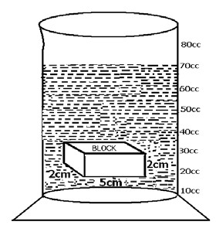53. **The experiment below was performed by a P.4 class.**

(a) What was the experiment intended to find out?

……………………………………………………………………………………………

………………………………………………………………………………………….

(b) Name the method.

…………………………………………………………………………………………………………

(c) What volume of water was in the can? (2 marks).

…………………………………………………………………………………………………………………….…………………………

54(a) What is excretion?

……………………………………………………………………………………………………………………………………………………

…………………………………………………………………………………………………………………….…………………………

(b) Name the organs responsible for the excretion of the wastes below? (i) Carbon dioxide

……………………………………………………………………………………………………………………………………………………

1. Urea

……………………………………………………………………………………………………………………………………………………

1. sweat

……………………………………………………………………………………………………………………………………………………

55. **Match items in A with those in B.**

|  |  |
| --- | --- |
| **A** | **B** |
| **Hydro electricity** | **Fuels** |
| **Solar electricity** | **Circuit** |
| **Thermal electricity** | **Running water** |
| **Electricity path** | **Sun** |

(a) Hydroelectricity ………………………………………………………………………………………………………………. (b) Solar electricity ………………………………………………………………………………………………………………. (c) Thermal electricity …………………………………………………………………………………………………………… (d) Electric path ………………………………………………………………………………………………………………….